Laxmi Charitable Trust’s
Sheth L.U.J College of Arts & Sir M.V. College of Science and Commerce
Department of Information Technology (B.Sc.I.T Semester V)
Dot .Net Core and Progressive Web Application Practical
Practical – VIII
Roll No.: T023 | Name: Som Mishra
Class: TYIT | Batch: 1
Date of Assignment: 06/08/26 | Date/Time of Submission: 06/08/26

- Create an HTML page that would be the starting point of the application. This HTML will contain a link to the file named manifest.json. This is an important file that would be created in the next step.

Code:-
Index.cshtml
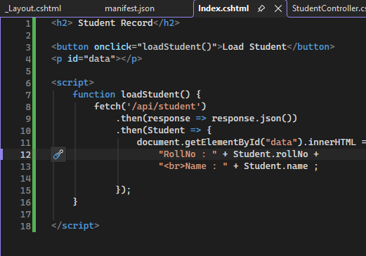
Manifest.json

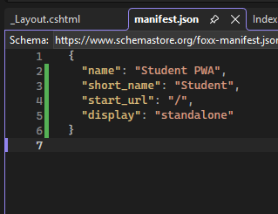

Layout.cshtml:
<link rel="manifest" href="/manifest.json" />

Output:-
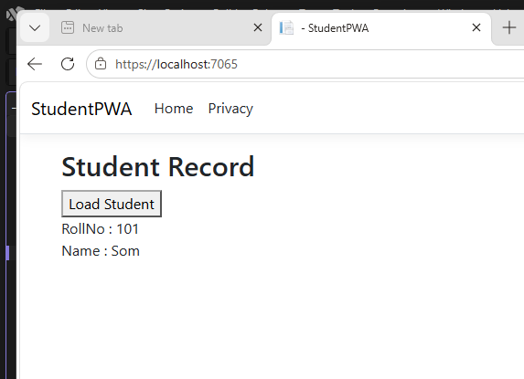

b. Create a simple Web API that returns Student data in JSON format.

Code:-
Student.cs
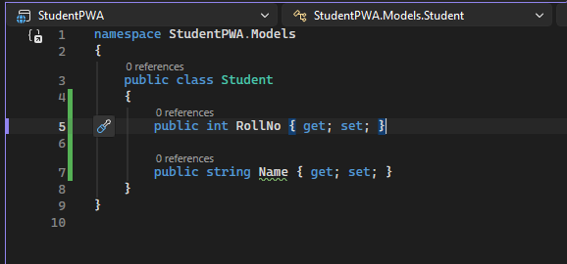

StudentController.cs
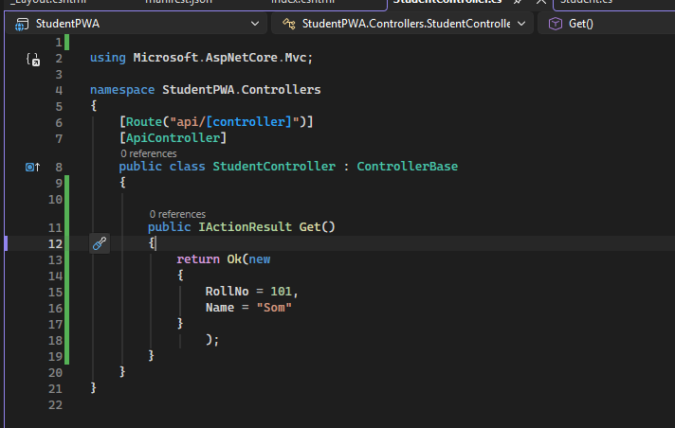

Output:-
